**Report: Revolutionizing News Browsing with Knowledge Hub**

**Table of Contents:**

1. Introduction

2. Vision and Mission of Knowledge Hub

3. Key Features and Functionality

4. User Experience Enhancements

5. Login and Registration System

6. Personalization and Customization Options

7. Navigation and Content Discovery

8. API Integration and Real-Time News Feed

9. Feedback Mechanism and Quality Assurance

10. Conclusion and Future Developments

11. Comparison with Times of India

---

**1. Introduction:**

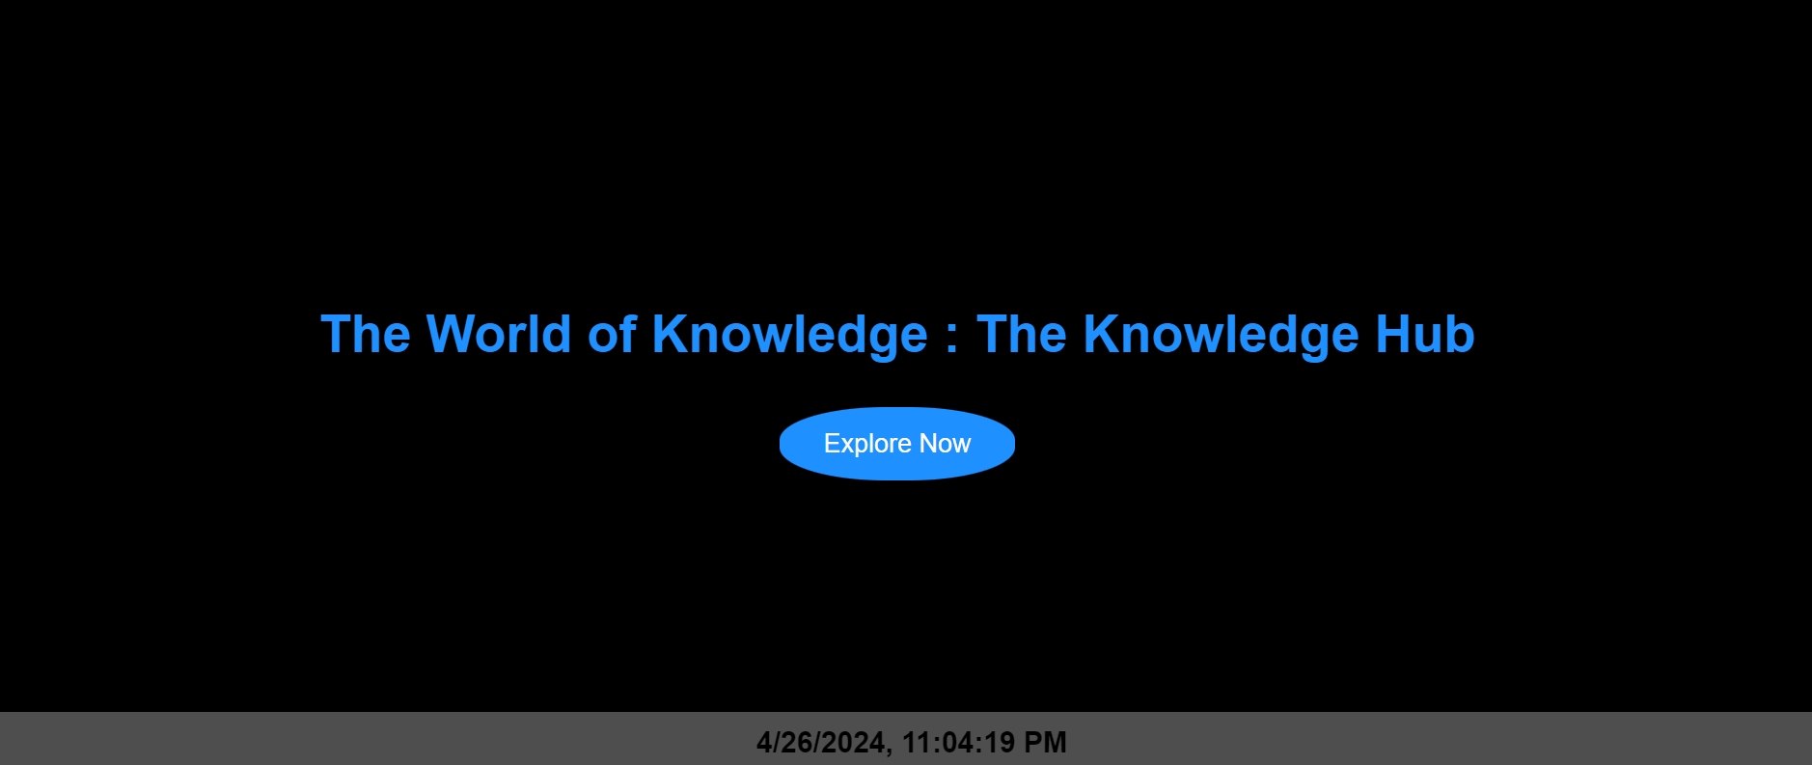

Knowledge Hub is a revolutionary news website aimed at transforming the way users browse and interact with news content. With a focus on user-centric design, personalized features, and real-time updates, Knowledge Hub seeks to provide an immersive and engaging news browsing experience for users worldwide.

---

**2. Vision and Mission of Knowledge Hub:**

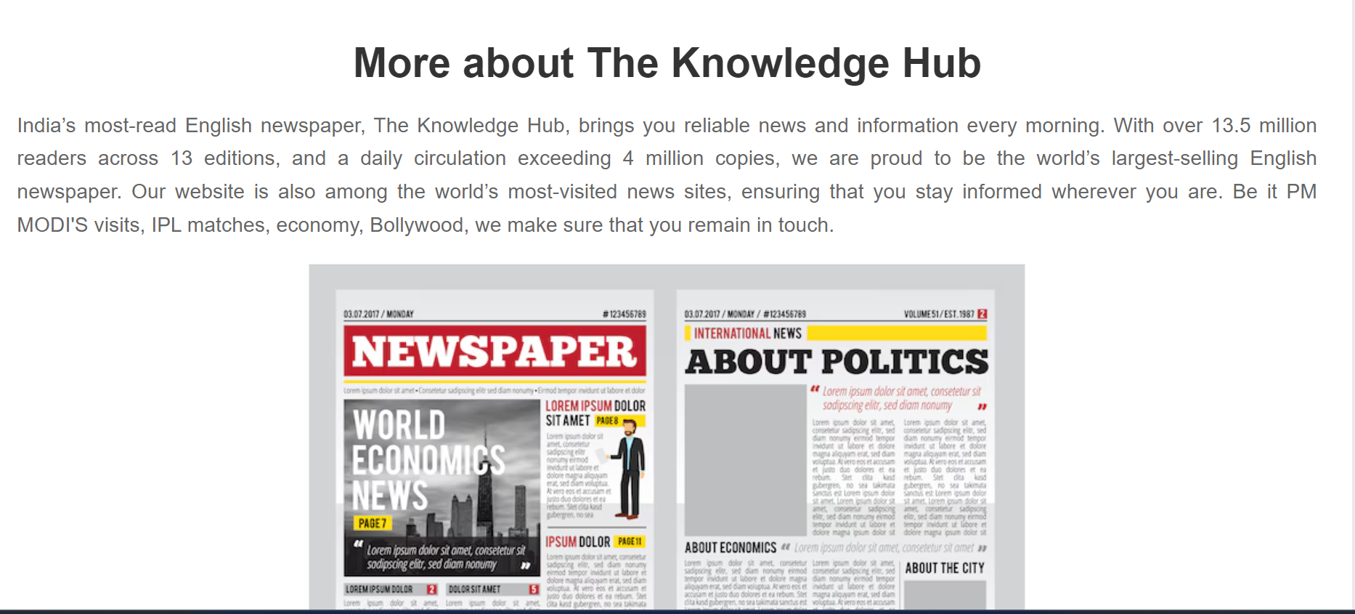

**Vision:** To become the go-to destination for users seeking personalized, real-time news updates and a seamless browsing experience.

**Mission:** To leverage cutting-edge technology, user feedback, and continuous innovation to deliver a dynamic and interactive news platform that empowers users to stay informed, engaged, and connected.

---

**3. Key Features and Functionality:**

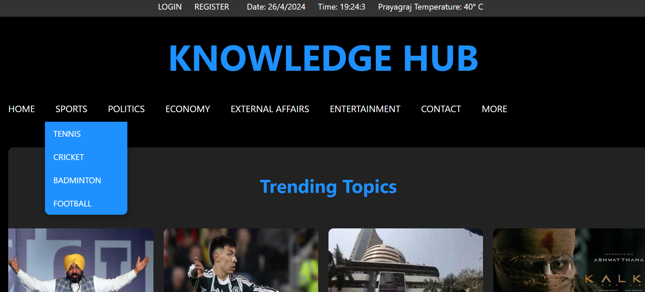

**-** **Live Date, Time, and Temperature Display:** A dynamic header on the homepage provides users with real-time information, enhancing their browsing experience and keeping them informed.

**- Trending Topics Section:** Curated content showcasing the latest news trends worldwide, allowing users to stay up-to-date with current events and popular discussions.

**- Opinion Polls Section:** Interactive polls on trending topics, enabling users to share their opinions and engage with other community members.

**- Your Picks Section:** Personalized news feeds based on user preferences, allowing users to tailor their news consumption experience and discover content relevant to their interests.

**- Dropdown Menu Navigation:** Easy access to various news categories, providing users with seamless navigation and content discovery options.

**- API Integration:** Real-time news updates and search functionality powered by third-party APIs, ensuring users have access to the latest information and content.

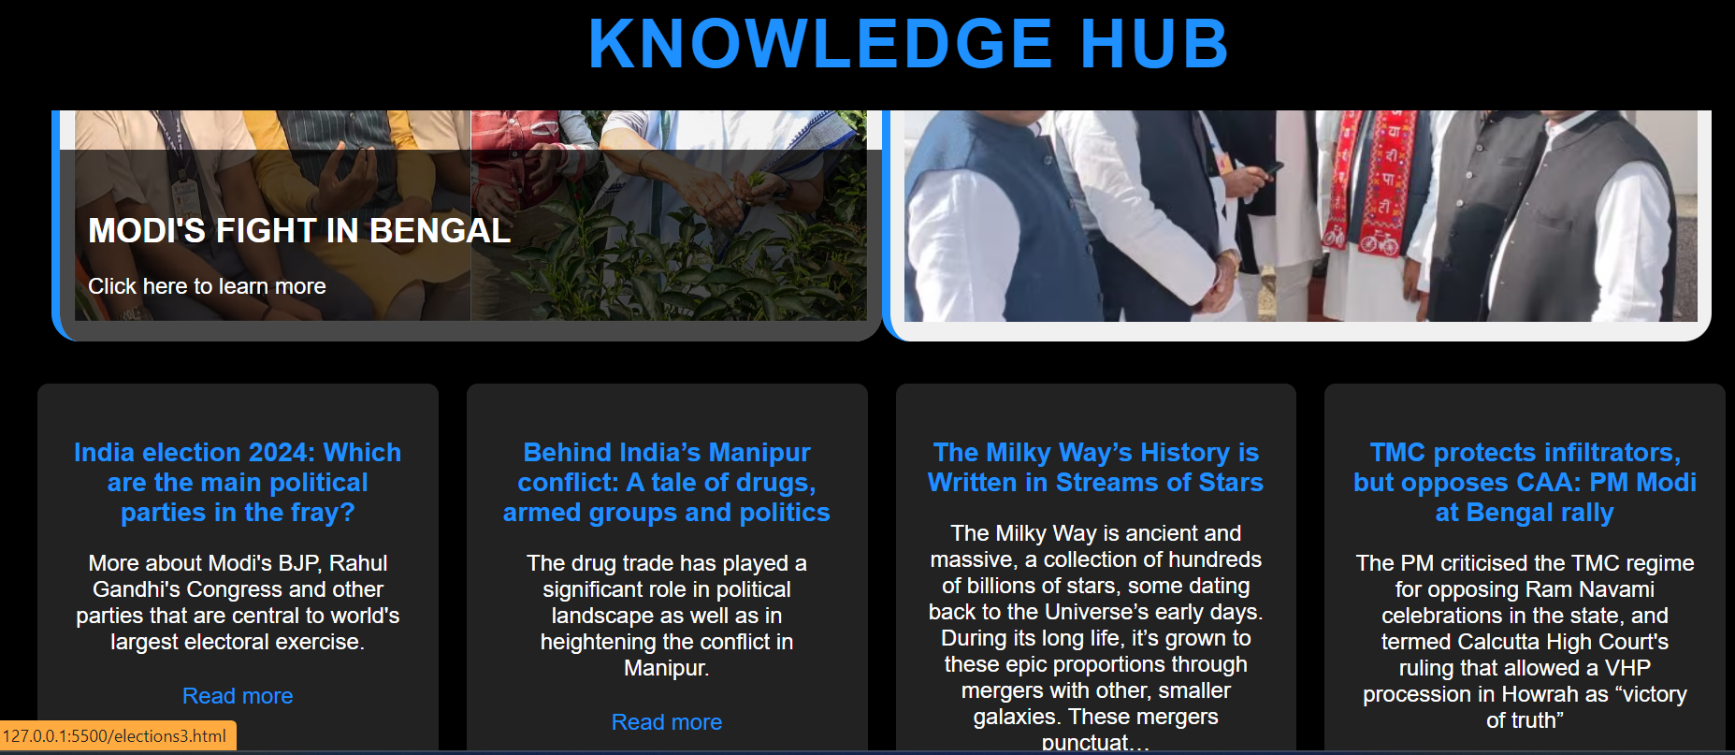

**- Feedback Mechanism:** Built-in feedback forms and submission portals for users to report errors, provide suggestions, and contribute to the improvement of the platform.

---

**4. User Experience Enhancements:**

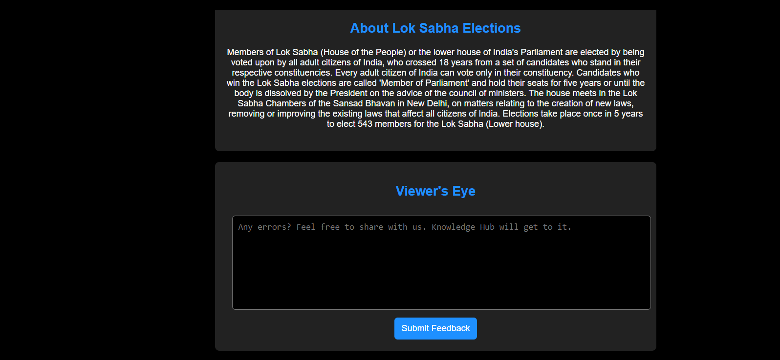

**- Clean and Intuitive Interface:** A user-friendly design with intuitive navigation and layout, ensuring an enjoyable and hassle-free browsing experience for users.

**- Engaging Visuals:** Eye-catching design elements, interactive features, and rich media content to capture users' attention and encourage exploration.

**- Mobile-Responsive Layout:** Responsive design optimized for various devices and screen sizes, allowing users to access the platform seamlessly on desktops, tablets, and smartphones.

**- Personalization Options:** Customizable settings and preferences, enabling users to tailor their experience according to their interests, browsing habits, and preferences.

---

**5. Login and Registration System:**

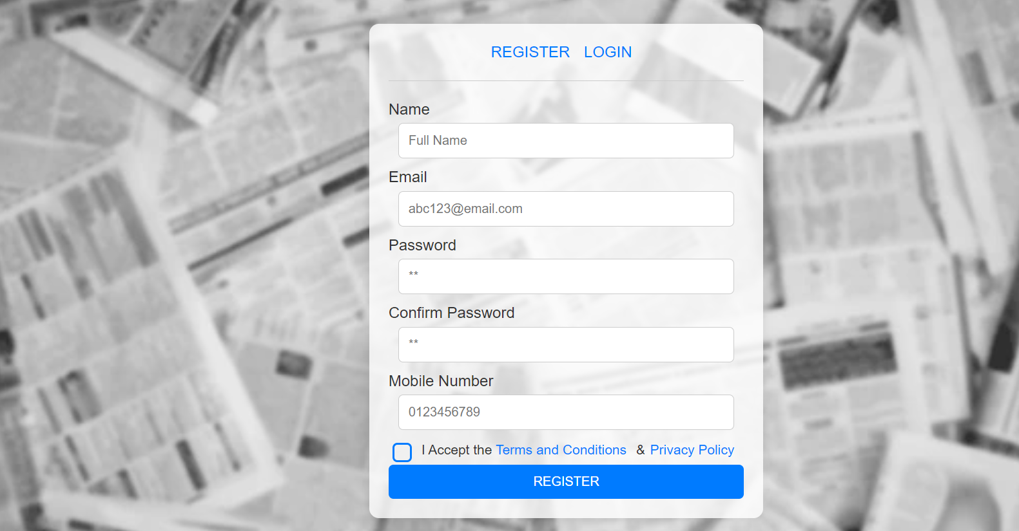

**- Secure Authentication:** Robust authentication protocols and encryption mechanisms to protect user data and ensure account security.

**- Seamless Registration Process:** User-friendly registration forms and account creation steps, minimizing friction and streamlining the onboarding process for new users.

**- Password Recovery and Account Management:** Built-in features for password recovery, account activation, and profile management, empowering users to manage their accounts conveniently.

---

**6. Personalization and Customization Options:**

**- Customizable News Feeds:** User-controlled settings and preferences for customizing news feeds, allowing users to filter content based on topics, keywords, and sources.

**- Interactive Forms and Prompts:** Engaging prompts and interactive forms to collect user input and preferences, facilitating personalized content recommendations and suggestions.

**- Event Listeners and Data Storage:** Data collection and storage mechanisms to track user interactions, preferences, and behavior, enabling dynamic content updates and personalized recommendations.

**- User Profile Settings:** Dedicated user profile sections for managing preferences, viewing history, and accessing personalized recommendations and settings.

---

**7. Navigation and Content Discovery:**



**- Dropdown Menu Navigation:** Intuitive navigation menus and dropdowns for easy access to various news categories, topics, and sections, enhancing content discovery and exploration.

**- Search Functionality:** Robust search functionality with autocomplete suggestions and advanced filtering options, enabling users to find relevant content quickly and efficiently.

**- Featured Sections and Recommendations:** Curated content sections, featured articles, and personalized recommendations to highlight trending topics, popular discussions, and recommended content.

**- Cross-Linking and Related Articles:** Cross-linking between articles, related content recommendations, and contextual links to encourage deeper exploration and engagement with the platform.

---

**8. API Integration and Real-Time News Feed:**

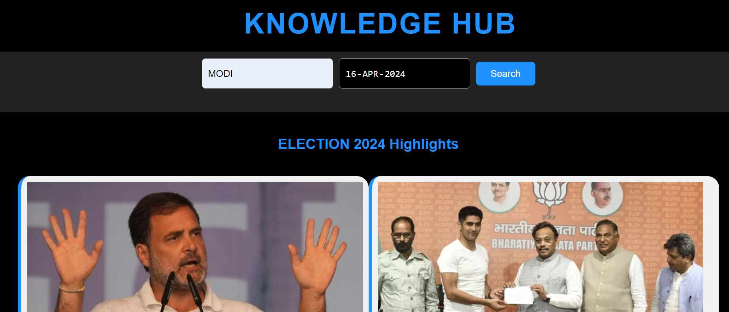

- **Integration of Third-Party APIs:** Seamless integration of third-party APIs to access real-time news data, updates, and content from various sources and providers.

- **Dynamic Content Rendering:** Dynamic content rendering based on API responses, user interactions, and preferences, ensuring users receive timely and relevant information tailored to their interests.

- **Error Handling and Data Validation:** Robust error handling mechanisms, data validation checks, and quality assurance processes to ensure data accuracy, reliability, and consistency.

- **Continuous Monitoring and Optimization:** Ongoing monitoring, optimization, and maintenance of API usage, performance, and scalability to deliver a seamless and reliable news browsing experience for users.

---

**9. Feedback Mechanism and Quality Assurance:**

- **Built-in Feedback Forms:** User-friendly feedback forms, submission portals, and contact channels for users to report errors, provide suggestions, and share feedback with the platform administrators.

- **Dedicated Quality Assurance Team:** Experienced quality assurance professionals and moderators responsible for reviewing user feedback, identifying issues, and implementing improvements and fixes.

- **Iterative Development Process:** Agile development methodology, iterative release cycles, and continuous improvement initiatives based on user feedback, analytics, and industry best practices.

- **Transparency and Accountability:** Transparent communication channels, reporting mechanisms, and accountability frameworks to address user-reported errors, resolve issues, and maintain trust and credibility with users.

---

**10. Conclusion and Future Developments:**

Knowledge Hub is committed to revolutionizing the news browsing experience by offering a dynamic and engaging platform that caters to the diverse needs and preferences of our users. Moving forward, we will continue to innovate and enhance the platform to deliver even greater value and utility to our growing community of users.

---

**11. Comparison with Times of India:**

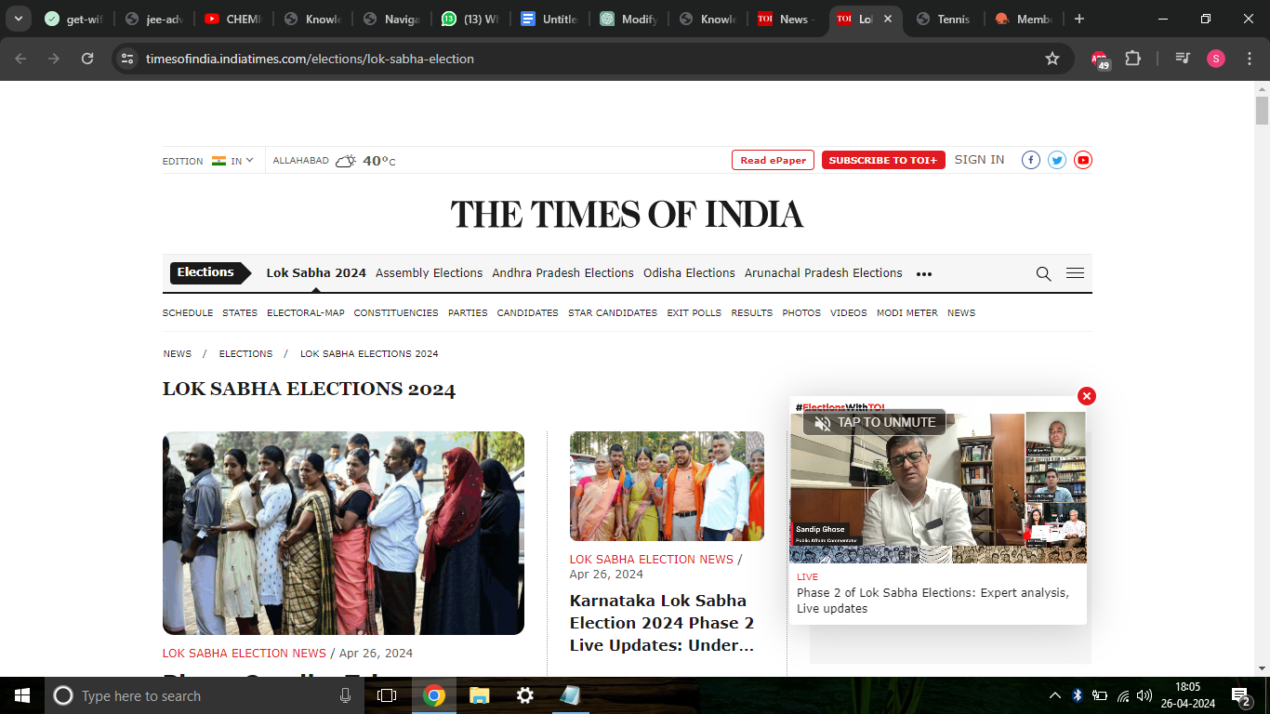



When comparing Knowledge Hub with traditional news websites like Times of India, several key differences emerge:

**1.** **User-Centric Design:** Knowledge Hub prioritizes user experience with a clean, intuitive interface and personalized features, whereas Times of India may appear cluttered and overwhelming to users.

**2. Personalization Options:** Knowledge Hub offers customizable news feeds and interactive features like opinion polls, allowing users to tailor their browsing experience to their preferences. Times of India may lack such personalized features, providing a one-size-fits-all approach to news consumption.

**3. Real-Time Updates:** With API integration and real-time news feeds, Knowledge Hub delivers the latest information as it happens, ensuring users stay informed and up-to-date. In contrast, Times of India may rely on manual updates and periodic content refreshes, leading to potential delays in news delivery.

**4.** **Feedback Mechanism:** Knowledge Hub actively solicits user feedback and suggestions, fostering a collaborative environment for continuous improvement. Times of India may have limited avenues for user engagement and feedback, resulting in a less interactive experience for users.

Overall, Knowledge Hub sets itself apart by offering a modern, user-centric approach to news browsing, enhancing engagement, and empowering users with personalized features and real-time updates.

---

**Conclusion:**

In conclusion, Knowledge Hub is committed to revolutionizing the news browsing experience by offering a dynamic and engaging platform that caters to the diverse needs and preferences of our users. Moving forward, we will continue to innovate and enhance the platform to deliver even greater value and utility to our growing community of users.

**Website Owners:**

* **Saumya Agrawal - IIT2023098**
* **Daksh Bhatti - IIT2023099**
* **Pritam Choudhary - IIT2023102**
* **Mukesh Samardha - IIT2023071**